Scenario — “Smart Banking System”
A new digital banking system has been launched by TrustBank.
Customers can access their accounts through mobile apps, ATMs, or directly at the bank branch.
- A customer opens the mobile app or visits an ATM to check balance, transfer money, pay bills, or withdraw cash.
- For every operation, the system first asks for authentication (PIN, password, or fingerprint). If the authentication fails after three attempts, the account is temporarily locked.
- When a customer requests a fund transfer, the system checks the account balance. If funds are enough, the transfer request goes through a payment gateway to send money to another account (inside or outside the bank). If the balance is insufficient, the request is rejected.
- Customers can also schedule bill payments, which are processed automatically on the due date.
- In case of any unusual activity (large transfer, multiple failed logins, access from a new device), the system triggers a fraud alert and notifies the security team.
- Inside the bank branch, tellers can help customers with deposits, withdrawals, and account updates. Managers can approve loans, freeze accounts, or view reports.
- The system stores all customer details, transaction records, and account information in a secure database.
- The IT department monitors servers, manages backups, and ensures the system is available for customers 24/7.

Use Case Diagram
• Actors: Who interacts with the system? (Customers, Teller, Manager, ATM, Payment Gateway, Security Team, etc.)
• Use Cases: Check balance, transfer funds, pay bills, withdraw cash, Deposit, Login, Manage accounts etc.
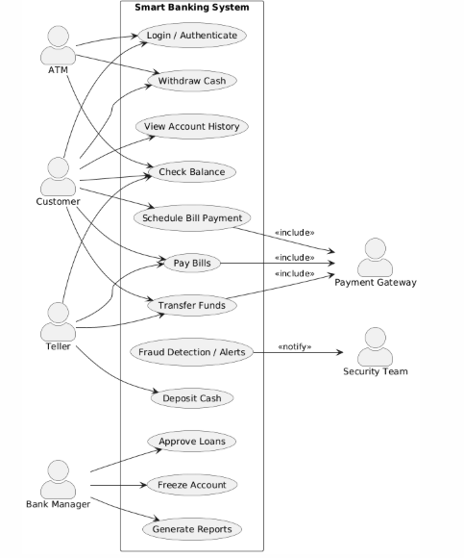

Activity Diagram
Activity Flow: For example, steps of “Money Transfer” (Login → Verify → Check Balance → Transfer → Confirm).
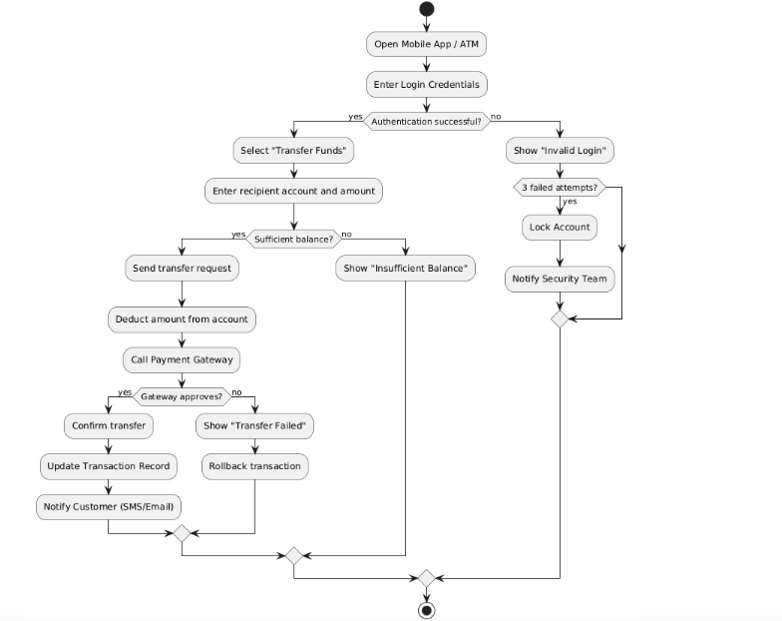

Sequence Diagram of “Money Transfer”
Sequence: Messages between Customer → App → Server → DB → Payment Gateway
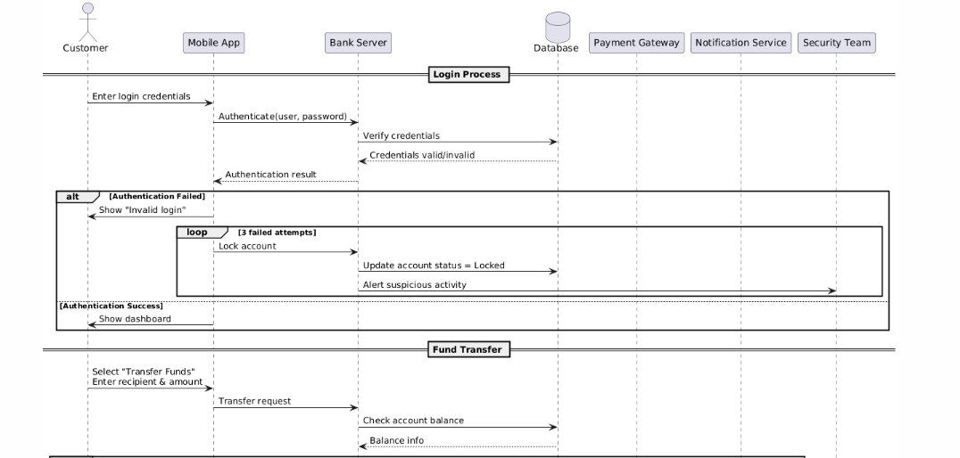
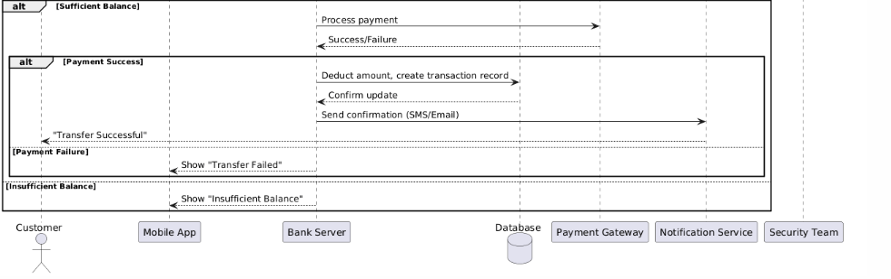

State Diagram
States: Account states (Active, Locked, Closed), Transaction states (Pending, Completed, Failed)
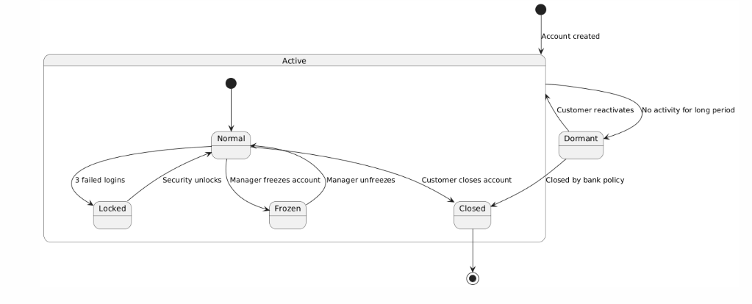

Class diagram
Classes: Account, Customer, Transaction, Loan, BillPayment, etc
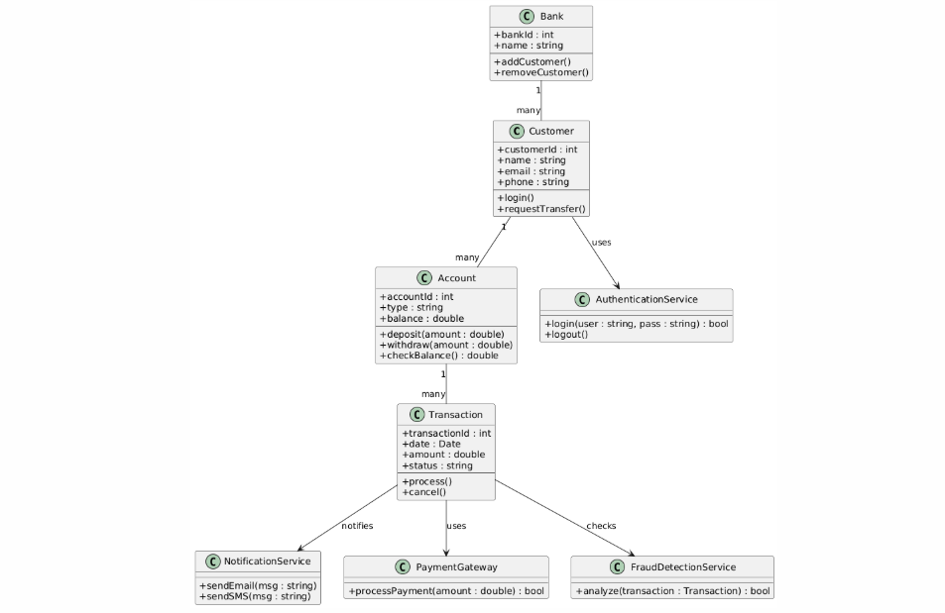

Component Diagram
Components: Mobile App, ATM System, Bank Server, Payment Gateway, Database
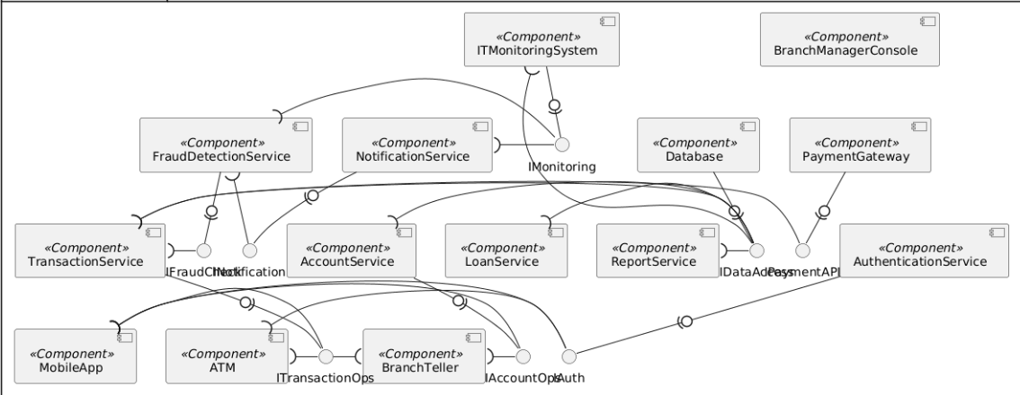

Deployment Diagram
Deployment: Mobile devices, ATM machines, Bank servers, Database server, External payment systems
